using System;

namespace Abdullah_Sadiq_CP_Lab_3

{

class Program

{

static void Main(string[] args)

{

Console.WriteLine("Enter your Name");

String name = Console.ReadLine();

Console.WriteLine("Enter Your Age");

int age = Convert.ToInt32(Console.ReadLine());

Console.WriteLine("Enter your salary");

int salary = Convert.ToInt32(Console.ReadLine());

Console.WriteLine("Enter Your Height");

double Height = Convert.ToDouble(Console.ReadLine());

Console.WriteLine("|\tName:{0}\t|\n|\tAge:{1} \t|\n|\tSalary:{2} \t|\n|\tHeight:{3} \t|", name,age,salary,Height);

}

}

}

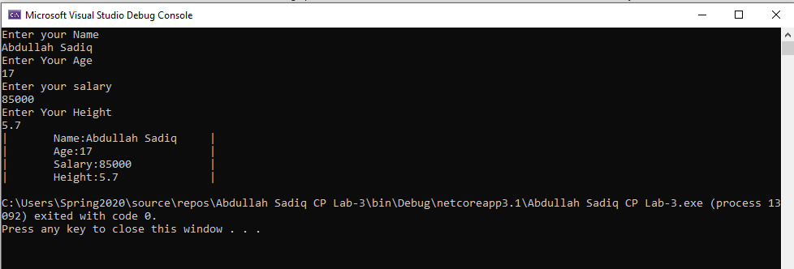

Task No 01: Convert Fahrenheit to Celsius

Input:

using System;

namespace Abdullah_Sadiq_CP_Lab_3

{

class Program

{

static void Main(string[] args)

{

Console.WriteLine("Enter Temperature in Fahrenheit");

int f = Convert.ToInt32(Console.ReadLine());

int c = (f - 32)*5/9;

Console.WriteLine("The Temperature in Celcius is {0}", c);

}

}

}

Output

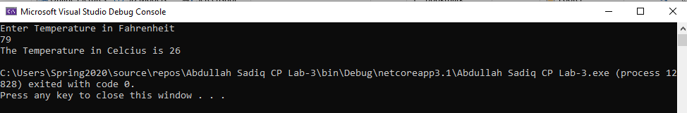

Task No 02: Calculate Area Of Circle

Input:

using System;

namespace Abdullah_Sadiq_CP_Lab_3

{

class Program

{

static void Main(string[] args)

{

int r = 8;

Console.WriteLine("Radius = 8cm");

Console.WriteLine("Pie = 22/7");

float a = r * r * 22 / 7;

Console.WriteLine("Area of Circle is {0}", a);

}

}

}

Output;

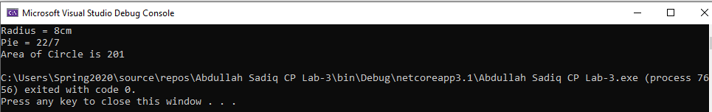

Task No 03: calculate value of Vf from equation of motion

Input:

using System;

namespace Abdullah_Sadiq_CP_Lab_3

{

class Program

{

static void Main(string[] args)

{

int vi = 43;

int a = 3;

int t = 15;

Console.WriteLine("Initial Velocity is 43 m/s");

Console.WriteLine("Time = 15s");

Console.WriteLine("Acceleration = 3m/ss");

int vf = vi = a * t;

Console.WriteLine("Final Velocity is {0}", vf);

}

}

}

Output:

